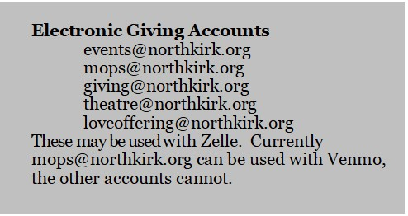

You may also use the link below to give through PayPal. Please use the “Friends and Family” option when using PayPal.
https://paypal.me/northkirk

